Additional Configs For Ease Of Use

- bashrc configs: add these in your ~/.bashrc file for ease of use.
  - This is used to give names to your tab in terminal.
function t(){
if [[ -z "$ORIG" ]]; then
ORIG=$PS1
fi
TITLE="\[\e]2;$*\a\]"
PS1=${ORIG}${TITLE}
}
    - Commad: t terminal_1
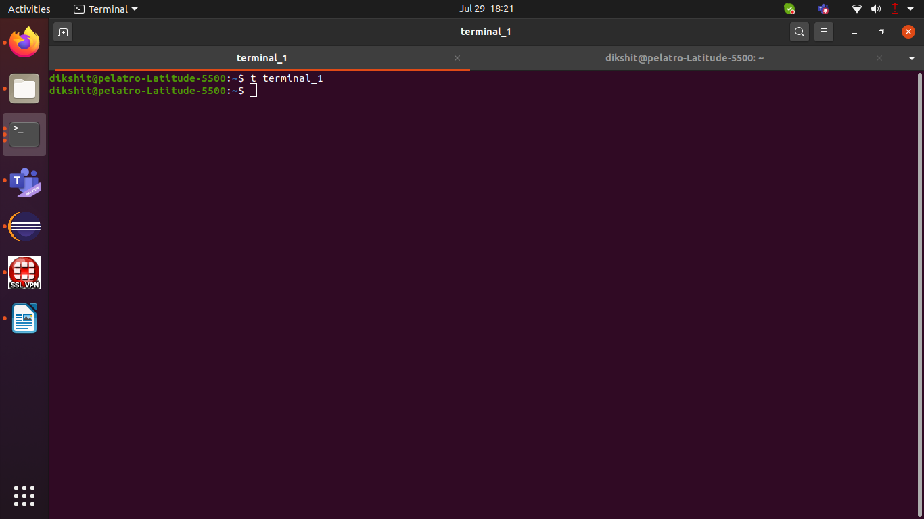
  - alias vJava='java -version'
    - you can use this to find java version easily.
    - Command : vJava
  - alias sourceBash='source ~/.bashrc'
    - you can use this to execute your bashrc script
    - Command: sourceBash
  - alias openBash='vi ~/.bashrc'
    - you can use this to open bashrc file
    - Command: openBash
  - alias java8="export JAVA_HOME=/usr/local/java/jdk1.8.0_241 && sourceBash && vJava"
    - this command is used to set java to version 8, execute bashrc and show java version
    - Command : java8
  - alias java7="export JAVA_HOME=/usr/local/java/jdk1.7.0_80 && sourceBash && vJava"
    - this command is used to set java to version 8, execute bashrc and show java version
    - Command : java7

